# Ex.No - 02

**Date - 24/07/2024**

TYPES OF CABLES

# AIM:

To study different types of Network cables.

## THEORY:

**Understand different types of network cable.**

Different type of cables used in networking are:

1. Unshielded Twisted Pair (UTP) Cable
2. Shielded Twisted Pair (STP) Cable
3. Coaxial Cable
4. Fibre Optic Cable

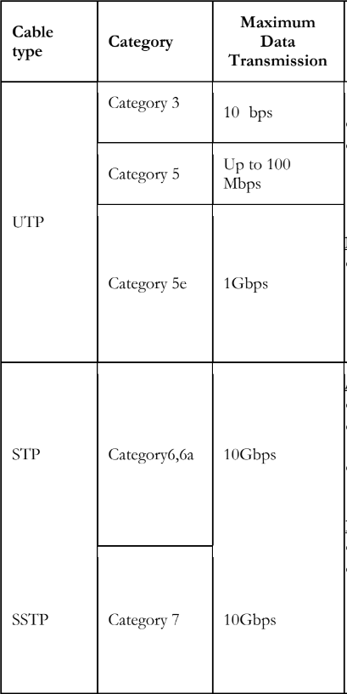

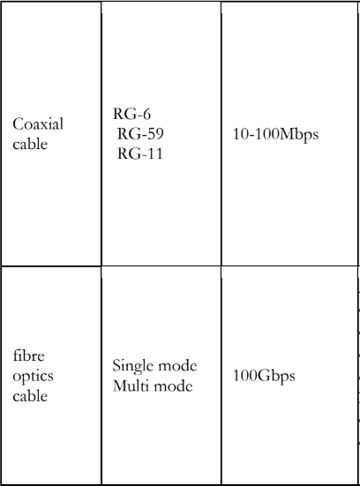

## Make Your Own Ethernet Crossover Cable/ Straight cable:

Tools and parts needed:

* Ethernet cabling. CAT5e is certified for gigabit support, but CAT5 cabling works as well, just over shorter distances.
* A crimping tool. This is an all-in-one networking tool shaped to push down the pins in the

plug and strip and cut the shielding off the cables.

* Two RJ45 plugs.
* Optional two plug shields.

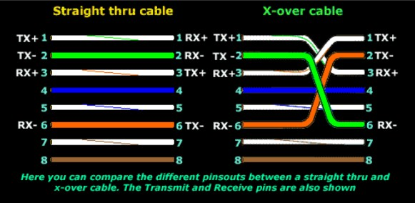

## Steps to connect a device :

**Step 1:** To start construction of the device, begin by threading shields onto the cable.

**Step 2:** Next, strip approximately 1.5 cm of cable shielding from both ends. The the crimping tool has a round area to complete this task.

**Step 3:** After, you will need to untangle the wires; there should be four “twisted pairs.” Referencing back to the sheet, arrange them from top to bottom. One end should be in arrangement A and the other in B.

**Step 4:** Once the order is correct, bunch them together in a line, and if there are any that stick out farther than others, snip them back to create an even level. The difficult aspect is placing these into the RJ45 plug without messing up the order. To do so, hold the plug with the clip side facing away from you and have the gold pins facing toward you.

**Step 5:** Next, push the cable right in. The notch at the end of the plug needs to be just over the cable shielding, and if it isn’t, that means that you stripped off too much shielding. Simply snip the cables back a little more.

**Step 6:** After the wires are securely sitting inside the plug, insert it into the crimping tool and push down.

It should be shaped correctly, but pushing too hard can crack the fragile plastic plug.

**Step 7:** Lastly, repeat for the other end using diagram B (to make a crossover cables)/ using diagram A (to make a straight through cable)

# RESULT:

The different types of network cables have been studied.